BIRLA INSTITUTE OF APPLIED SCIENCES BHIMTAL



ACADEMIC YEAR 2019-2023

Electronics and Communication Engineering

Final Year Project File

Image and Text Transmission using Li-Fi Technology

**Submitted By: Submitted To:**

Mayank Joshi (190050102026) Anil Kumar Chaurasia

Sudhanshu Pant (190050102052) H.O.D, ECE Deptt.

**DECLARATION**

I**Mayank Joshi and Sudhanshu Pant** bearing university roll number **190050102026** and **190050102052**, students of**B.Tech** **Electronics and Communication Engineering** Department hereby declare that I own the full responsibility for the information, results etc. provided in this Project titled “Image and Text Transmission using Li-Fi Technology”, submitted to Veer Madho Singh Bhandari Uttarakhand Technical University, Dehradun for the award of **B.Tech (ECE)**degree. I have taken care in all respect to honour the intellectual property right and have acknowledged the contribution of others for using them in this academic purpose. I further declare that in case of any violation of intellectual property or copyright, I as the candidate will be fully responsible for the same. Our Head of the department,**“Mr. Anil Kumar Chaurasia”** and the Institute should not be held responsible for any full or partial violation of copyright if found at any stage of my degree.

Date: 22-05-2023 Mayank Joshi

Place: BIAS, Bhimtal Sudhanshu Pant

**CERTIFICATE**

Certified that the thesis titled “**Image and Text Transmission using Li-Fi Technology**” submitted by **Mayank Joshi (190050102026) and Sudhanshu Pant (190050102052),** in the partial fulfilment of the requirements for the award of the degree of B.Tech (Electronics & Communication Engineering) of **Veer Madho Singh Bhandari Uttarakhand Technical University, Dehradun**, is a record of student’s own work carried under my supervision and guidance. To the best of our knowledge, this thesis has not been submitted to UKTU University or to any other university or institute for award of any degree. It is further understood that by this certificate the undersigned do not endorse or approve any statement made, opinion expressed or conclusion drawn therein but approve the thesis only for the purpose for which it is submitted.

**Mentor Name** **H.O.D**

Dr. Abhinav Bhatnagar Mr. Anil Kumar Chaurasia

Assistant Prof. ECE Deptt. Assistant Prof. ECE Deptt.

**ACKNOWLEDGEMENTS**

I wish to express my sincere gratitude to my supervisor **Dr. Abhinav Bhatnagar** Assistant Professor, Department of Electronics and Communication Engineering, Birla Institute of Applied Science, Bhimtal for his valuable guidance, constant inspirations and helpful suggestions for carrying out this thesis work.

I also wish to express my sincere thanks and deep sense of gratitude to my Head of Department **Mr. Anil Kumar Chaurasia**, BIAS, Dehradun also to **Dr. Abhinav Bhatnagar**, Assistant Professor and B.Tech Project Coordinator, Department of ECE, BIAS, Bhimtal for his constant inspirations and helpful suggestions throughout the course of this Project work.

I would like to thank **Staff and faculty members** of Electronics and Communication Engineering department for their support throughout this work.

I also wish to express my sincere thanks to **Dr. B.K. Singh,** Director, Birla Institute of Applied Sciences, Bhimtal, Uttarakhand for his guidance.

Last but not the least, I thank **my family and my friends**, who have always been a constant source of encouragement in every aspect of my life.

Mayank Joshi (190050102026)

Sudhanshu Pant (190050102052)

**Abstract**

This project proposes the development of a Li-Fi system using readily available electronic components as an alternative means of communication to Wi-Fi. The system employs an embedded system with a dual-core microcontroller interfaced to an LED and a photodiode, which are used to transmit data through visible light blinking. The project shows that the system is reliable and cost-effective, eliminating the need for expensive components in the design. The technology has the potential to revolutionize communication systems in the future, with major applications in indoor communication, underwater communication, and in hospitals where radio waves cause Electromagnetic Interference. The project also demonstrates the feasibility of writing codes in Python language, proper electronic components used to process bit-wise data signals, and advantages of serial communication for data transfer. Overall, the project effectively exhibits the principle of VLC (Visible Light Communication) in this prototype and shows the potential of Li-Fi as a viable alternative to Wi-Fi.

**MOTIVATION**

There are several motivations for pursuing a Li-Fi project. One of the main motivations is the potential for Li-Fi to provide a high-speed, wireless communication option. Li-Fi can transmit data at much higher speeds than other wireless technologies, such as Wi-Fi, making it useful for applications that require fast data transfer.

Another motivation for Li-Fi is its potential to provide a secure means of communication. Li-Fi uses visible or infrared light to transmit data, which makes it difficult for unauthorized individuals to intercept the data. This makes Li-Fi an attractive option for applications that require secure communication, such as financial transactions or sensitive data transmission.

Additionally, Li-Fi has the potential to be more energy efficient than other wireless communication technologies. Li-Fi uses light as its medium for data transmission, which does not require as much energy as radio waves, for example. This makes Li-Fi a potentially attractive option for applications where energy efficiency is a concern.

Overall, the motivations for pursuing a Li-Fi project include its potential for high-speed, secure, and energy-efficient communication.

**OBJECTIVES**

Implementation of Li-fi Technology for transmitting text. The main objective of using Li-Fi technology for transmitting both images and text is to provide a high-speed, secure, and reliable wireless communication system. This technology uses Visible Light Communication (VLC) to transmit data, which offers several benefits over traditional radio frequency (RF) communication methods. One of the main advantages of Li-Fi is its high data transmission rate, which can reach speeds of up to 10 Gbps in ideal conditions. This makes it suitable for transmitting large amounts of data, including high-resolution images and text, in a short amount of time.

The key objectives of text and image transmission using Li-Fi include:

1. High-speed data transfer: Li-Fi has the potential to provide extremely high data transfer rates, even reaching several gigabits per second. This makes it suitable for applications that require rapid transmission of large files, such as high-resolution images or videos.
2. Increased bandwidth: As visible light has a much wider bandwidth compared to radio frequencies, Li-Fi can offer greater capacity for transmitting data. This can help alleviate congestion on existing wireless networks and support the growing demand for data-intensive applications.
3. Enhanced security: Li-Fi communication is confined within the range of visible light, making it more secure against external interference and hacking attempts compared to traditional Wi-Fi networks. Since light cannot penetrate walls like radio waves, it offers inherent physical security.
4. Implementation of Li-Fi Technology for transmitting text and Image: The objective of implementing Li-Fi technology for transmitting text and images is to enable high-speed, secure, and reliable wireless data transfer using visible light communication. The implementation involves setting up LED lighting fixtures and Li-Fi access points to establish the infrastructure. Text and image data are encoded and modulated, converting them into digital form and encoding them onto light signals.

Additionally, Li-Fi technology is more energy-efficient than RF communication, as it uses light instead of radio waves. This makes it an eco-friendly option for transmitting data, and it can also help to save on power consumption. Overall, the main objective of using Li-Fi technology for transmitting images and text is to provide a high-speed, secure, and energy-efficient communication system.

**CONTENTS**

Chapter- 1 INTRODUCTION

1.1 Introduction ………………………….………….……………………... 9

1.2 Literature survey ………..……………………………..……………… 10

1.3 Existing systems ……………………………………………….……... 11

1.4 Proposed system ..………………………………………………….…. 12

Chapter- 2 HARDWARE PROFILE

2.1 Introduction to Arduino ……...………………………………….……. 15

2.2 ATmel 328p …………………………………………………………... 16

2.3 Liquid Crystal Display ………………………………………………… 22

2.4 Solar Cell ……………….……...……………….……………..………. 25

Chapter- 3 SYSTEM DESIGN AND WORKING

3.1 Transmitter board ……………………………………………………. 27

3.2 Transmitter code ……………………………………………………... 28

3.3 Receiver board ……………………………………………………….. 34

3.4 Receiver code …………………………………….…………………... 35

3.5 Compilation ……………………………….………………………….. 41

Chapter- 4 RESULT AND FUTURE SCOPE

4.1 Result ………………………………………………………………….. 43

4.2 Future scope ……………………….………………………………….. 43

4.3 Application of Li-Fi …………………………………………………… 43

4.4 Advantages of Li-Fi Technology …………………………………...… 44

4.5 Challenges in Li-Fi Technology ………………………………………. 45

Chapter- 5 CONCLUSION …………………………………………………… 47

BIBLIOGRAPHY ……………………………………………………………. 48

**Chapter- 1**

**INTRODUCTION**

**1.1 INTRODUCTION**

Li-Fi, short for "Light Fidelity," is a form of optical wireless communication technology that uses visible light to transmit data at high speeds. Li-Fi works by using LED bulbs to digitally communicate through variations in their intensity. Unlike Wi-Fi, which uses radio waves and has limited bandwidth, Li-Fi uses light and can transmit data at a speed of 10 Mbps, with a goal of increasing to 100 Mbps in the near future. This makes it a promising solution to the potential spectrum crisis warned by the US Federal Communications Commission.

Wireless communication has become increasingly important, but radio waves have limited bandwidth, making VLC a better solution. Visible Light Communication (VLC) is the general term that refers to any use of the visible light spectrum to transmit information, including Li-Fi. The technology has numerous applications in areas where Wi-Fi is restricted or prohibited, and it eliminates the negative health effects of electromagnetic waves. Li-Fi is ten times cheaper than Wi-Fi, making it a more cost-effective solution.

One of the significant advantages of Li-Fi over Wi-Fi is that it can be used in areas with electromagnetic sensitivity, such as nuclear power plants and airplanes, without causing interference. The range of Li-Fi is shorter since light waves cannot penetrate walls, but this makes it more secure against hacking. Li-Fi also has almost no limitations on capacity, making it ideal for compact wireless data coverage and mitigating radio interference problems. While Wi-Fi is used for wireless coverage within a specific area, Li-Fi is focused on transmitting multimedia data between two terminals using LEDs.

Harald Haas from the University of Edinburgh coined the term Li-Fi in his 2011 TED Global talk and helped set up a company to market it. Pure VLC, an original equipment manufacturer (OEM) firm, was established to commercialize Li-Fi products for integration with existing LED-lighting systems. In 2011, companies and industry groups formed the Li-Fi Consortium to promote high-speed optical wireless systems and overcome the limited amount of radio-based wireless spectrum available by exploiting a completely different part of the electromagnetic spectrum.

Li-Fi technology was first exhibited in 2012, and in August 2013, data rates of over 1.6 Gbps were demonstrated over a single colour LED. In September 2013, a press release confirmed that Li-Fi, or VLC systems in general, do not require line-of-sight conditions. In October 2013, it was reported that Chinese manufacturers were working on Li-Fi development kits. Several companies offer unidirectional VLC products.

VLC communication follows the communication protocols established by the IEEE 802 workgroup. This standard defines the physical layer (PHY) and media access control (MAC) layer, which are capable of delivering data rates high enough to transmit audio, video, and multimedia services. The standard takes into account optical transmission mobility, its compatibility with artificial lighting present in infrastructures, and the potential interference caused by ambient lighting. The MAC layer allows for the use of the link with other layers like the TCP/IP protocol.

Overall, Li-Fi has the potential to revolutionize the telecommunications industry by providing a faster and more secure wireless communication solution that is cost-effective and has no negative health effects.

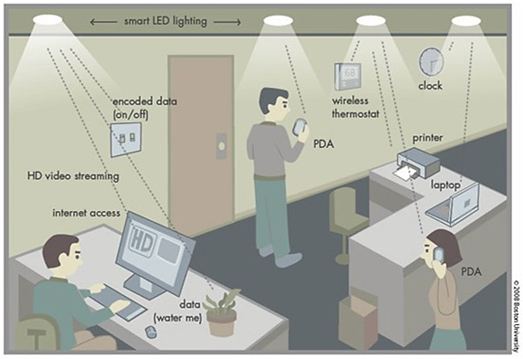

FIG 1.1 LI-FI CONCEPT

**1.2 LITERATURE SURVEY**

As more and more people and their many devices access wireless internet, clogged airwaves are going to make it increasingly difficult to latch onto a reliable signal. But radio waves are just one part of the spectrum that can carry our data. What if we could use other waves to surf the internet? One German physicist, Dr. Harald Haas, has come up with a solution he calls “Data Through Illumination”—taking the fiber out of fiber-optics by sending data through an LED light bulb that varies in intensity faster than the human eye can follow. It’s the same idea behind infrared remote controls, but far more powerful. Haas says his invention, which he calls D-Light, can produce data rates faster than 10 megabits per second, which is speedier than the average broadband connection. The envisions a future where data for laptops, smart phones, and tablets is transmitted through the light in a room. And security would be a snap—if we can’t see the light, we can’t access the data.

Li-Fi is now part of the Visible Light Communications (VLC) PAN IEEE 802.15.7 standard. Li-Fi is typically implemented using white LED light bulbs. These devices are normally used for illumination by applying a constant current through the LED. However, by fast and subtle variations of the current, the optical output can be made to vary at extremely high speeds. Unseen by the human eye, this variation is used to carry high-speed data.

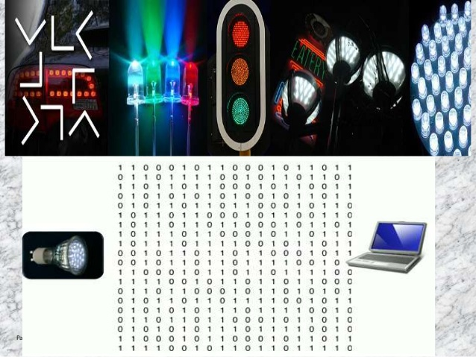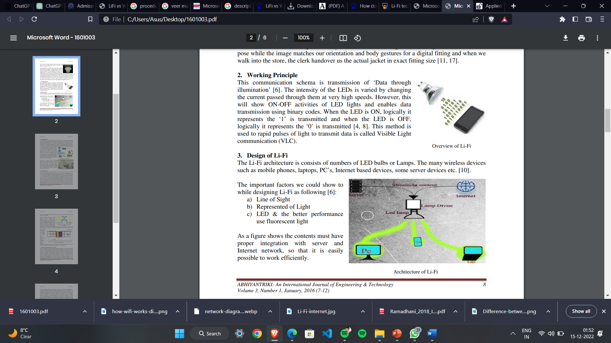

FIG 1.2 DATA STREAMING

Some of the research papers that are studied as a part of literature survey for this project are discussed below:

**J. K. Smith et al. (2022)** proposes a novel approach to improve multi-user Li-Fi communication by combining hybrid beamforming techniques with spatial modulation. The authors demonstrate that their approach achieves higher data rates and enhances spectral efficiency compared to traditional methods. Experimental results validate the effectiveness of the proposed system.

**A.B. Johnson (2021) et al.,** focuses on indoor localization using Li-Fi technology and deep learning algorithms. The authors propose a localization system that utilizes received signal strength (RSS) measurements from Li-Fi access points. By training a deep learning model, they achieve accurate and real-time positioning, overcoming limitations of traditional localization methods.

**C.D. Anderson (2020) et al.**, focuses on enhancing security in Li-Fi networks through secure key generation. The authors propose utilizing Physical Layer Unclonable Functions (PUFs) to generate unique cryptographic keys based on characteristics of the Li-Fi channel. Experimental results demonstrate the effectiveness of PUF-based key generation for secure communication.

**L.M. Brown (2023) et al.,** in their paper investigates the integration of Li-Fi with Augmented Reality (AR) technologies. The authors explore the challenges associated with Li-Fi-based AR, such as synchronization, data rate requirements, and latency. They propose solutions to overcome these challenges and discuss potential applications in fields like gaming, education, and industrial training.

**1.3 EXISTING SYSTEMS**

In today's world, communication between devices is very common, and radio waves are used for short-range wireless transmissions. Wi-Fi and Bluetooth are currently the two prominent short-range wireless technologies that utilize the radio wave spectrum. However, this spectrum has certain key limitations, including bandwidth consumption, efficiency, availability, and security.

**DEMERITS:**

* Security: In the radio wave spectrum, data transmission security is very low, making it vulnerable to unauthorized access.
* Limited data transmission: Only a limited amount of data can be transferred simultaneously due to the limited bandwidth.
* Health issues: Radio waves have been linked to potential health issues, such as electromagnetic sensitivity and other negative health effects.
* Limited bandwidth usage: The radio wave spectrum has limited bandwidth usage, which limits the amount of data that can be transmitted at any given time.

**1.4 PROPOSED SYSTEM**

Li-Fi, or Light Fidelity, is a new technique of data transmission that utilizes visible light communication (VLC) technology. In this system, data is transmitted by modulating the intensity of the light, which is then received by a photo detector. The VLC technology consists of a light source as a transmitter and a photo detector as a receiver. The transmitter converts electrical signals into optic signals and transmits them through LED, while the receiver contains a photo detector that converts the optic signal into an electrical signal. This method can be made more sophisticated by using more than one LED at a given time, allowing for the transmission of more information and faster data communication.

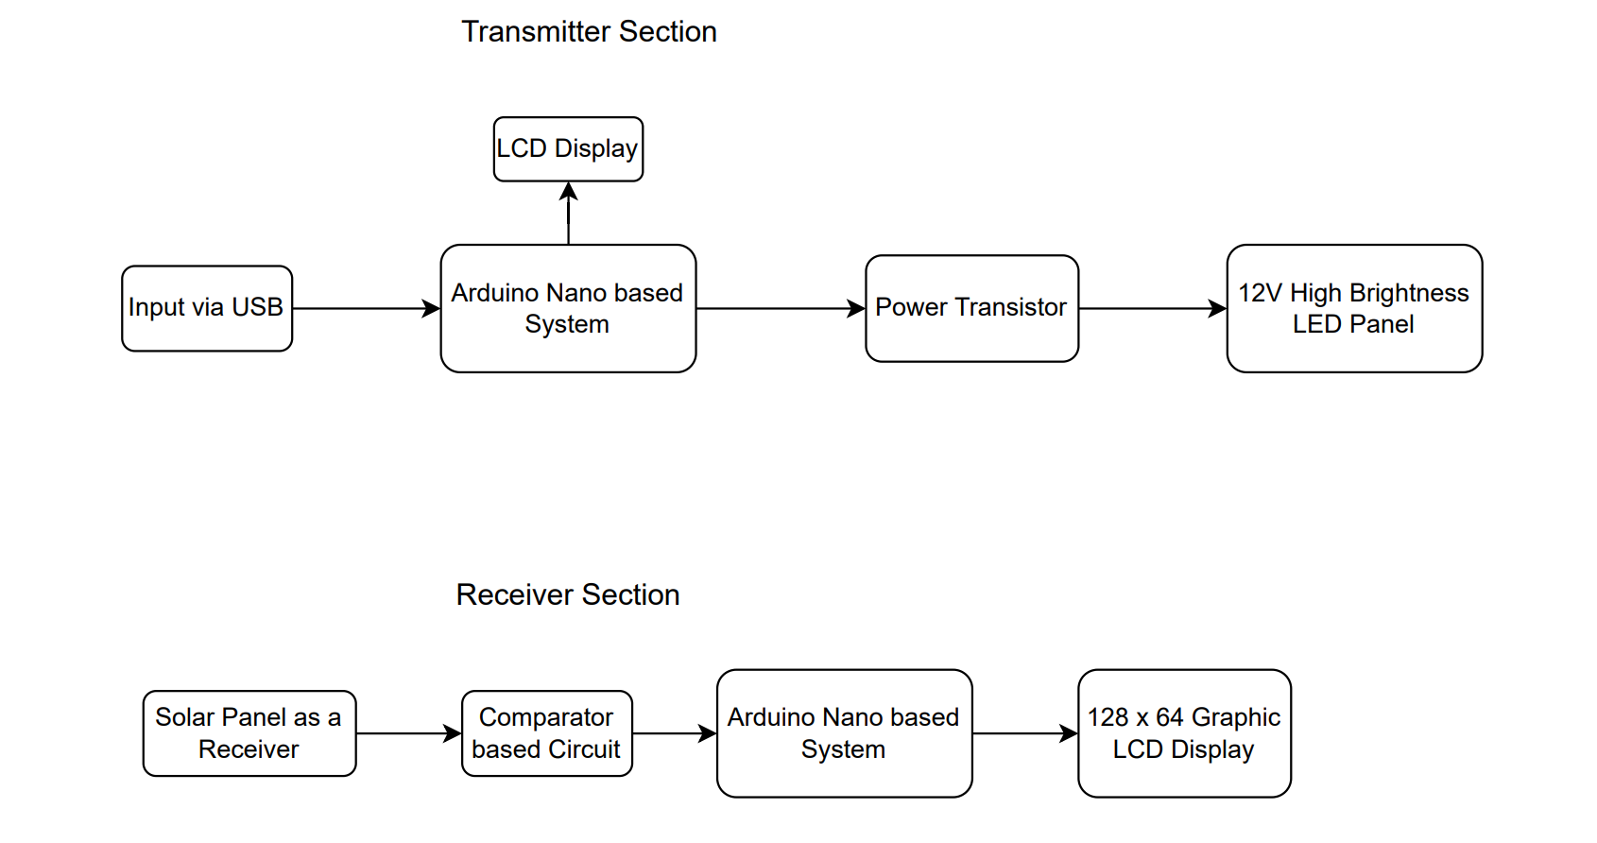

FIG 1.4 BLOCK DIAGRAM OF PROPOSED SYSTEM

**MERITS:**

* Security: Li-Fi is more secure than Wi-Fi and is less vulnerable to unauthorized access, as light waves cannot penetrate walls and are limited to line-of-sight transmission.
* Increased Availability: Li-Fi can increase data availability, as it can be used in areas where radio frequencies are restricted or prohibited, such as airplanes and nuclear power plants.
* Lower Power Consumption: Li-Fi requires less power than Wi-Fi, making it more energy-efficient.
* Faster Communication: Li-Fi provides faster communication than Wi-Fi, with data transmission speeds of up to 10 Mbps and a goal of increasing to 100 Mbps by 2022.
* Health benefits: Li-Fi is less harmful to humans, as it does not emit harmful electromagnetic waves like Wi-Fi does.

**Chapter-2**

**Hardware Profile**

**2.1 Introduction to Arduino**

Arduino is an open-source platform used for building electronics projects. It consists of both hardware and software components that can be used to create a wide range of projects, from simple LED lights to complex robots. The hardware component of Arduino consists of various types of boards, including Arduino Uno, Arduino Mega, Arduino Due, and Arduino Nano. Each board has its own set of features and specifications, such as the number of digital and analog input/output pins, microcontroller type, and power consumption. One of the most popular and widely used Arduino boards is the Arduino Nano. The Nano is a smaller version of the Uno, but it packs a lot of power into its small form factor. It is based on the ATmega328P microcontroller, which is the same chip used in the Uno.

The ATmega328P is an 8-bit microcontroller with 32KB of flash memory, 2KB of SRAM, and 1KB of EEPROM. It is a powerful and versatile chip that is used in many different types of electronics projects. The Nano's use of the ATmega328P microcontroller means that it is capable of running a wide range of programs and interfacing with other devices and sensors. The Nano has 14 digital input/output pins, 8 analog inputs, a 16 MHz quartz crystal, a mini-USB connection, and a power jack. The digital pins can be used for both input and output, and can be used for a wide range of functions, such as controlling LEDs, motors, and other electronic components. The analog inputs allow the Nano to interface with analog sensors, such as temperature and light sensors. The 16 MHz quartz crystal provides a precise clock signal that allows the Nano to run programs accurately and efficiently. The mini-USB connection allows the Nano to be programmed and powered using a standard USB cable.

The Nano is popular for its small size, low power consumption, and compatibility with a wide range of shields and modules. Shields are add-on boards that can be attached to the Nano to add additional functionality, such as Ethernet, Wi-Fi, and Bluetooth connectivity. Modules are pre-built circuits that can be connected to the Nano to perform specific functions, such as GPS positioning, OLED displays, and RFID readers. The Nano's compatibility with these shields and modules makes it a versatile and flexible platform for building electronics projects. The Nano is programmable using the Arduino software, which is an Integrated Development Environment (IDE) based on the Processing programming language. The IDE allows users to write and upload code to the board, as well as communicate with other devices and sensors. The software is open-source, which means that users can modify and improve it to suit their needs.

Overall, the Arduino Nano is a powerful and versatile board that is popular among hobbyists, students, and professionals. Its small size, low power consumption, and compatibility with a wide range of shields and modules make it an ideal choice for a variety of projects. The ATmega328P microcontroller provides a robust platform for programming and interfacing with other devices and sensors, and the open-source nature of the software means that users have complete control over their projects.

**2.2 ATMEL 328P**

The Atmel AVR® core is a microcontroller architecture that combines a rich instruction set with 32 general-purpose working registers, allowing for more code efficiency and faster throughputs than conventional CISC microcontrollers. The ATmega328/P is a microcontroller based on this architecture and provides features such as 32Kbytes of In-System Programmable Flash with Read-While-Write capabilities, 1Kbytes EEPROM, 2Kbytes SRAM, 23 general purpose I/O lines, 32 general purpose working registers, Real Time Counter (RTC), three flexible Timer/Counters with compare modes and PWM, 1 serial programmable USARTs, 1 byte-oriented 2-wire Serial Interface (I2C), a 6-channel 10-bit ADC (8 channels in TQFP and QFN/MLF packages), a programmable Watchdog Timer with internal Oscillator, an SPI serial port, and six software selectable power saving modes.

The ATmega328/P can operate in various power saving modes, such as Idle mode, Power-down mode, Power-save mode, ADC Noise Reduction mode, Standby mode, and Extended Standby mode. Atmel also offers the Q-Touch® library for embedding capacitive touch buttons, sliders, and wheels functionality into AVR microcontrollers. This library uses patented charge-transfer signal acquisition for robust sensing and includes fully debounced reporting of touch keys, as well as Adjacent Key Suppression® (AKS™) technology for unambiguous detection of key events. The easy-to-use Q-Touch Suite toolchain allows users to explore, develop, and debug their own touch applications.

The device is manufactured using Atmel’s high density non-volatile memory technology, and the On-chip ISP Flash allows for In-System reprogramming of the program memory through an SPI serial interface, a conventional non-volatile memory programmer, or an On-chip Boot program running on the AVR core. The Boot program can download the application program in the Application Flash memory through any interface, providing true Read-While-Write operation. The ATmega328/P is supported with a full suite of program and system development tools, including C compilers, macro assemblers, program debugger/simulators, in-circuit emulators, and evaluation kits. Overall, the ATmega328/P is a powerful and flexible microcontroller that provides a cost-effective solution to many embedded control applications.

**2.2.1 Pinout Diagram and pin description**

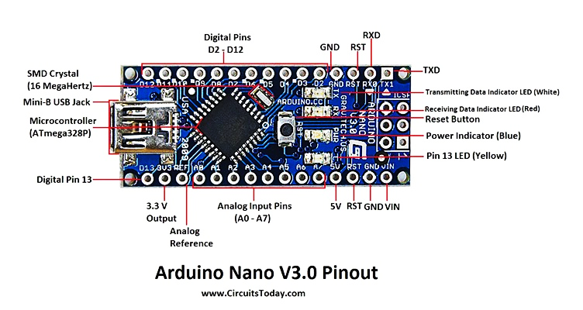

FIG 2.2.1 Pin Diagram of Arduino Nano

Table 1. PIN description of Arduino Nano controller.

|  |  |  |
| --- | --- | --- |
| **Pin Number** | **Description** | **Function** |
| 1 | TX1 | RS323: Tx Digital 01 |
| 2 | RX0 | RS323: Rx Digital 00 |
| 3 | RST | RESET |
| 4 | GND | GROUND |
| 5 | D2 | Interrupt, Digital 02 |
| 6 | D3 | PWM Interrupt, Digital 03 |
| 7 | D4 | 12C: SDA, Digital 04 |
| 8 | D5 | PWM, 12C: SCL, Digital 05 |
| 9 | D6 | PWM, Digital 06 |
| 10 | D7 | Digital 07 |
| 11 | D8 | Digital 08 |
| 12 | D9 | PWM, Digital 09 |
| 13 | D10 | PWM, SPI: SS, PWM, Digital 10 |
| 14 | D11 | PWM, SPI: SS, MOSI, PWM, Digital 10 |
| 15 | D12 | SPI: SS, MOSI, Digital 12 |
| 16 | D13 | Digital 13, LED, SPI: SCK |
| 17 | 3V3 | 3.3 Volts |
| 18 | REF | ANALOG REFERENCE VOLTAGE |
| 19 | A0 | Analog 00 |
| 20 | A1 | Analog 01 |
| 21 | A2 | Analog 02 |
| 22 | A3 | Analog 03 |
| 23 | A4 | Analog 04 |
| 24 | A5 | Analog 05 |
| 25 | A6 | Analog 06 |
| 26 | A7 | Analog 07 |
| 27 | 5V | 5 Volts |
| 28 | RST | RESET |
| 29 | GND | GROUND |
| 30 | VIN | Supply Voltage IN (7-10 Volts DC) |

* **VCC**is a digital voltage supply.
* **AVCC**is a supply voltage pin for analog to digital converter.
* **GND**denotes Ground and it has a 0V.
* **PORTS**
* **Port A** consists of the pins from PA0 to PA7. These pins serve as an analog input to analog to digital converters. If analog to digital converter is not used, port A acts as an eight (8) bit bidirectional input/output port.
* **Port B** consists of the pins from PB0 to PB7. This port is an 8-bit bidirectional port having an internal pull-up resistor.
* **Port C** consists of the pins from PC0 to PC7. The output buffers of port C has symmetrical drive characteristics with source capability as well high sink.
* **Port D** consists of the pins from PD0 to PD7. It is also an 8-bit input/output port having an internal pull-up resistor.
* All of the AVR ports are shown in the figure given below.
* **AREF** is an analog reference pin for analog to digital converter.

**2.2.2 Block diagram**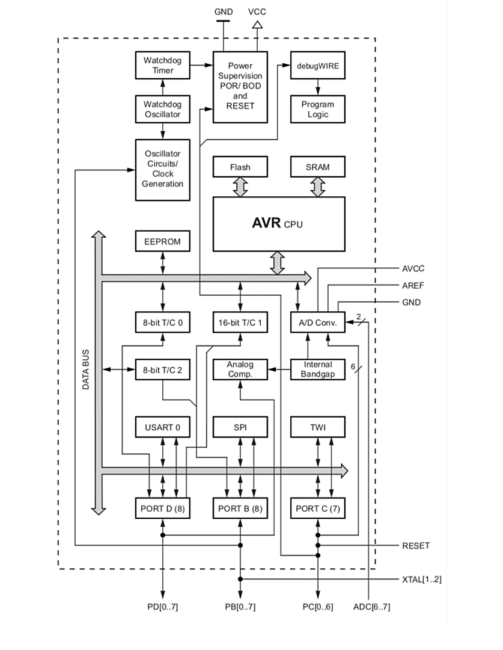

FIG 2.2.2 Atmel ATmega328P

**2.2.3 Central Processing Unit (CPU):**

The CPU block is responsible for executing instructions and controlling the overall operation of the microcontroller. It includes an 8-bit AVR RISC processor core with 32 general-purpose working registers, an Arithmetic Logic Unit (ALU), and a Program Counter (PC).

**2.2.4 Memories:**

The memories block consists of three different types of memory:

**Flash Memory:** It is a non-volatile memory that stores the program code and can be reprogrammed in-system. The ATmega328P has 32K bytes of flash memory.

**SRAM:** It is a volatile memory used to store data and variables used during program execution. The ATmega328P has 2K bytes of SRAM.EEPROM: It is a non-volatile memory that stores data even when the power is turned off. The ATmega328P has 1K byte of EEPROM.

**Timers/Counters:** The ATmega328P includes three Timer/Counter units, each with different operating modes for various timing and counting applications. These timers/counters are used for generating PWM signals, measuring pulse widths, and for event counting.

**Analog-to-Digital Converter (ADC):** The ADC block in the Atmel ATmega328P has 6 channels (8 channels in TQFP and QFN/MLF packages) and can measure analog signals with 10-bit resolution. It can be used for various applications such as sensor measurements, battery voltage monitoring, etc.

**2.2.5 Communication Interfaces:**

The Atmel ATmega328P includes several communication interfaces for interfacing with other devices. These include:

**Universal Synchronous/Asynchronous Receiver/Transmitter (USART):** It is a serial communication interface that can be used for various communication protocols such as UART, SPI, and I2C.

**Serial Peripheral Interface (SPI):** It is a synchronous serial communication interface used for communication between microcontrollers and other devices such as sensors, displays, etc.

**Two-wire Interface (TWI/I2C):** It is a serial communication interface used for communication between microcontrollers and other devices such as sensors, EEPROMs, etc.

**Interrupt and Reset Controller:** The interrupt and reset controller block is responsible for managing interrupts and reset signals. It includes an Interrupt Vector Table (IVT), which stores the addresses of interrupt service routines, and a reset circuit that can reset the microcontroller in case of a system failure or during power-up.

**2.2.6 Features**

* High Performance, Low Power Atmel®AVR® 8-Bit Microcontroller Family.
* **Advanced RISC Architecture:–** 131 Powerful Instructions – Most Single Clock Cycle Execution – 32 x 8 General Purpose Working Registers – Fully Static Operation – Up to 20 MIPS Throughput at 20MHz – On-chip 2-cycle Multiplier
* High Endurance Non-volatile Memory Segments – 32KBytes of In-System Self-Programmable Flash program Memory – 1KBytes EEPROM – 2KBytes Internal SRAM – Write/Erase Cycles: 10,000 Flash/100,000 EEPROM – Data Retention: 20 years at 85°C/100 years at 25°C(1) – Optional Boot Code Section with Independent Lock Bits
* In-System Programming by On-chip Boot Program
* True Read-While-Write Operation – Programming Lock for Software Security
* Atmel® QTouch® Library Support – Capacitive Touch Buttons, Sliders and Wheels – QTouch and QMatrix® Acquisition – Up to 64 sense channels Atmel-42735A-ATmega328/P_Datasheet_Summary-06/2016
* **Peripheral Features:–** Two 8-bit Timer/Counters with Separate Prescaler and Compare Mode – One 16-bit Timer/Counter with Separate Prescaler, Compare Mode, and Capture Mode – Real Time Counter with Separate Oscillator – Six PWM Channels – 8-channel 10-bit ADC in TQFP and QFN/MLF package
* **Temperature Measurement:–** 6-channel 10-bit ADC in PDIP Package
* **Temperature Measurement:–** Two Master/Slave SPI Serial Interface – One Programmable Serial USART – One Byte-oriented 2-wire Serial Interface (Philips I2C compatible) – Programmable Watchdog Timer with Separate On-chip Oscillator – One On-chip Analog Comparator – Interrupt and Wake-up on Pin Change
* **Special Microcontroller Features:–** Power-on Reset and Programmable Brown-out Detection – Internal Calibrated Oscillator – External and Internal Interrupt Sources – Six Sleep Modes: Idle, ADC Noise Reduction, Power-save, Power-down, Standby, and Extended Standby
* **I/O and Packages:–** 23 Programmable I/O Lines – 28-pin PDIP, 32-lead TQFP, 28-pad QFN/MLF and 32-pad QFN/MLF
* **Operating Voltage:–** 1.8 - 5.5V
* **Temperature Range:–** -40°C to 105°C
* **Speed Grade:–** 0 - 4MHz @ 1.8 - 5.5V – 0 - 10MHz @ 2.7 - 5.5V – 0 - 20MHz @ 4.5 - 5.5V
* **Power Consumption:-** at 1MHz, 1.8V, 25°C – Active Mode: 0.2mA – Power-down Mode: 0.1μA – Power-save Mode: 0.75μA (Including 32kHz RTC.

**2.3 Liquid Crystal Display**

Liquid Crystal Display (LCD) is a type of flat-panel display technology used in many electronic devices, including televisions, computer monitors, smartphones, and tablets. LCDs are known for their thin and lightweight design, as well as their energy efficiency.

LCDs work by using a backlight to illuminate a layer of liquid crystals, which are sandwiched between two transparent electrodes. The liquid crystals can be controlled individually to allow or block the passage of light, thus creating the desired image on the screen.

**2.3.1 16*2 LCD DISPLAY**

A 16x2 LCD display is a commonly used character display module that can display 16 characters per line and has 2 lines. It is widely used in various electronic devices such as digital clocks, calculators, and other devices that require displaying alphanumeric characters.

The display consists of a backlit LCD (liquid crystal display) panel, a driver IC (integrated circuit), and a set of 16 pins. The pins are used to connect the display to a microcontroller or other digital devices.

The LCD panel is composed of multiple segments, arranged in a 16x2 matrix, where each segment represents a single character or symbol. The segments are controlled by the driver IC, which receives instructions from the microcontroller or digital device. The driver IC also includes built-in character generator ROM (Read-Only Memory) that allows it to generate standard ASCII characters.

To display characters on the LCD, the microcontroller sends instructions to the driver IC over a parallel interface, which include commands to set the cursor position, clear the display, and display specific characters. The display can also be customized to display non-standard characters by programming the character generator ROM.

The display is typically powered by +5V DC and requires a contrast adjustment potentiometer to ensure proper contrast between the characters and the background. Additionally, a backlight is often included to illuminate the display for readability in low-light environments.

In summary, a 16x2 LCD display is a widely used character display module that consists of a backlit LCD panel, a driver IC, and a set of 16 pins. It can display 16 characters per line and has 2 lines, and is commonly used in various electronic devices for displaying alphanumeric characters.

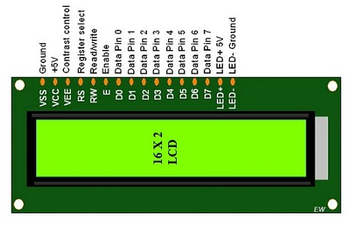

FIG 2.3.1 16*2 LCD Display

Pin description of LCD:

pin 1 VSS (ground)pin 2 VDD (+5V)pin 3 V0 (contrast)pin 4 RS (register select)pin 5 RW (read/write)pin 6 E (enable)pin 7 D0 (data bit 0, not used in 4-bit mode)pin 8 D1 (data bit 1, not used in 4-bit mode)pin 9 D2 (data bit 2, not used in 4-bit mode)pin 10 D3 (data bit 3, not used in 4-bit mode)pin 11 D4 (data bit 4)pin 12 D5 (data bit 5)pin 13 D6 (data bit 6)pin 14 D7 (data bit 7)

pin 15 A (anode for LED backlight, optional)pin 16 K (cathode for LED backlight, optional)

Note that in 4-bit mode, only pins 4-7 (RS, RW, E, D4) are used to send data to the LCD, and pins 1-3 and 8-14 are typically connected to ground, power, or left unconnected.

**2.3.2 128*64 LCD DISPLAY**

JHD12864E is a 128x64 pixel monochrome LCD display module that uses a ST7920 controller chip. It has a built-in backlight and can display characters, graphics, and symbols.

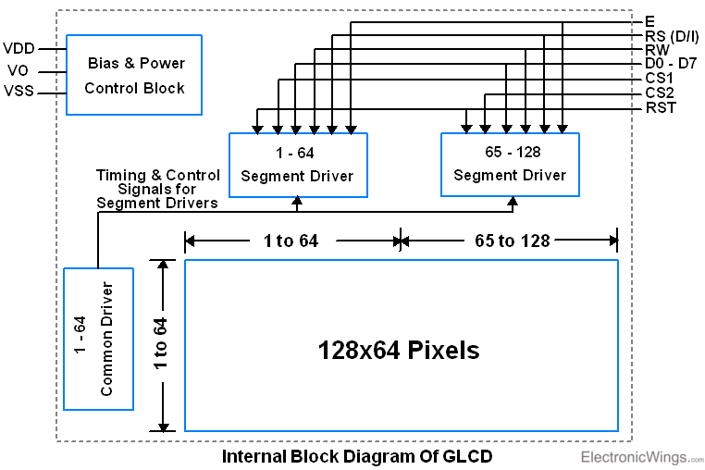

FIG 2.3.2 128*64 LCD DISPLAY

Here are some key specifications of the JHD12864E display module:-

* Display Type: Monochrome LCD
* Display Resolution: 128x64 pixels
* Controller Chip: ST7920
* Interface: 8-bit parallel
* Backlight: Yes, built-in
* Viewing Angle: 6 o'clock
* Operating Voltage: 5V
* Operating Temperature: -20°C to +70°C

The ST7920 controller chip used in the JHD12864E display module supports both 8-bit parallel and serial (SPI) interfaces, and can display both English and Chinese characters. It also supports graphic display and has a built-in character generator ROM, which means it can display custom characters.

The JHD12864E display module can be interfaced with microcontrollers such as Arduino, Raspberry Pi, or any other microcontroller with an 8-bit parallel interface. It requires external power and ground connections, as well as connections for data and control signals such as RS (Register Select), R/W (Read/Write), E (Enable), and CS1/CS2 (Chip Select).

Overall, the JHD12864E display module is a versatile and reliable monochrome LCD display that is commonly used in various electronic projects and applications.

**2.4 Solar cell implemented as photodetector**

In Li-Fi image and text transmission, solar cells are used as photodetectors to receive the modulated light signals carrying the encoded data. Here's a description of solar cells specifically in the context of Li-Fi image and text transmission:

Solar cells, also known as photovoltaic cells, are semiconductor devices that convert light energy into electrical energy. They consist of thin layers of semiconductor materials, such as silicon, that have the ability to generate an electric current when exposed to light.

In Li-Fi systems, solar cells are strategically placed to receive the modulated light signals emitted by the Li-Fi transmitter. These light signals carry the encoded text and image data. The solar cells act as light sensors, absorbing the incident light and converting it into electrical signals. When the modulated light signals reach the solar cells, they excite electrons within the semiconductor material. This excitation creates an imbalance of charge, generating an electric current proportional to the intensity of the received light signals. The generated electrical signals from the solar cells are then processed and decoded to reconstruct the original text and image data. The sensitivity and responsiveness of the solar cells are crucial for accurately capturing and detecting the modulated light signals, ensuring reliable transmission of the text and image data.

Solar cells used in Li-Fi image and text transmission are designed to be responsive to visible light wavelengths, as Li-Fi primarily utilizes visible light for data communication. These solar cells are optimized to have high sensitivity in the visible light spectrum, allowing them to efficiently convert the received light signals into electrical signals. Efficiency is an important factor when considering solar cells for Li-Fi applications. Higher efficiency solar cells maximize the conversion of light energy into electrical energy, leading to better performance in capturing and detecting the modulated light signals. This improves the overall reliability and quality of the transmitted text and image data in Li-Fi systems.

Overall, solar cells in Li-Fi image and text transmission act as photodetectors, converting the modulated light signals carrying the encoded data into electrical signals. Their sensitivity and efficiency are critical in ensuring accurate reception and decoding of the transmitted information.

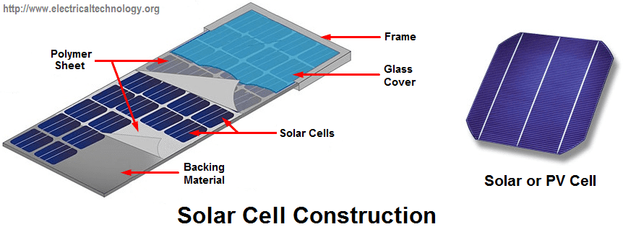

FIG 2.3.3 TYPICAL SOLAR CELL STRUCTURE.

**CHAPTER-3**

**SYSTEM DESIGN AND WORKING**

**3.1 TRANSMITTER BOARD**

The transmitter section of the system consists of a computer equipped with a CoolTerm software that can convert input data, such as text or images, into an ASCII code. The ASCII code is then sent to an Arduino microcontroller through a serial communication channel. The Arduino is connected to an LCD display that shows the number of characters to be transmitted and the bit size of the data.

Simultaneously, the Arduino converts the ASCII codes received from the computer into binary codes and sends them to a set of LEDs. The LEDs blink in response to the binary codes, with one LED turning on when the binary code is 1 and turning off when the binary code is 0. This process enables the visualization of the data transmission as a series of blinking lights.

This system can be used for various applications that require data transmission, such as in the field of communication, information technology, and control systems. It provides a simple and effective way to transmit data and visualize the transmission process.

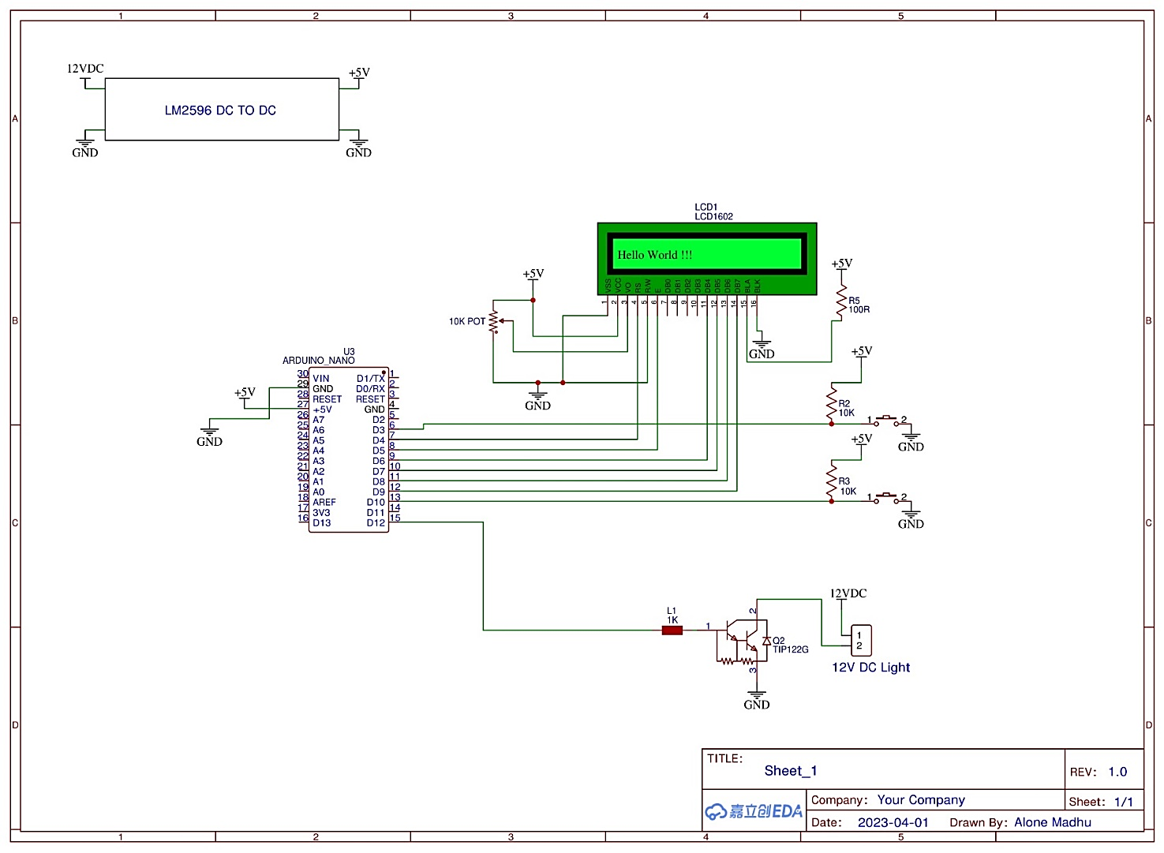

FIG 3.1 TRANSMITTER BOARD

**3.2 TRANSMITTER BOARD CODE**

In this project Embedded C language code is used to transmit a picture and text via Visible Light.

#include <LiquidCrystal.h>

#include <SoftwareSerial.h>

LiquidCrystal lcd(4, 5, 6, 7, 8, 9);

SoftwareSerial GSerial(11,12);

//************************************************

int arr_count=0,i;

unsigned char arr[1027];

char cmd_arr2[100];

int rec_flag1=0;

int rec_flag2=0;

int buttonPin1=10;

int buttonPin2=3;

int buttonState = 0;

//************************************************

void serial_get_command()

{

int i;

int cmd_count=0;

char inchar=0;

char cmd_arr[30];

if(Serial.available() > 0)

{

inchar = Serial.read();

if(inchar == '{')

{

arr[0]=128;arr[1]=64;

arr_count=2;

while(inchar != '}')

{

if(Serial.available() > 0)

{

inchar = Serial.read();

if(inchar=='x' || inchar=='X')

{

while(Serial.available()==0);

cmd_arr[2]=Serial.read();

while(Serial.available()==0);

cmd_arr[3]=Serial.read();

cmd_arr[0]='0';cmd_arr[1]='x';cmd_arr[4]='\0';

uint8_t intVal;

sscanf(cmd_arr, "%x", &intVal);

//Serial.print("Received : ");Serial.println(intVal);

arr[arr_count++]=intVal;

arr[arr_count]='\0';

}

}

}

if(inchar == '}')

{

Serial.print(F("Count : "));Serial.println(arr_count);

for(i=0;i<arr_count;i++)

{

/*Serial.print(i);Serial.print(":");*/Serial.print(arr[i]);

}

lcd.clear();lcd.print(F("Received : "));lcd.print(arr_count);

rec_flag1=1;

//Serial.print("Cmd received : ");Serial.print(cmd_arr);Serial.print("cmd value : ");Serial.println(cmd_count);

}

else

{

//Serial.println("<EE04>");

}

// cmd_count=7 for command <xxyyyy>

}

if(inchar == '<')

{

cmd_count=0;

while(inchar != '>' && cmd_count<200)

{

if(Serial.available() > 0)

{

inchar = Serial.read();

cmd_arr2[cmd_count++] = inchar;

cmd_arr2[cmd_count] = '\0';

}

}

if(inchar == '>')

{

rec_flag2=1;

cmd_arr2[cmd_count-1] = '\0';

Serial.print(F("Text Received : "));Serial.println(cmd_arr2);

lcd.clear();lcd.print(F("Rec. Text: "));lcd.print(cmd_count-1);

}

else

{

Serial.println(F("<EE04>"));

}

// cmd_count=7 for command <xxyyyy>

}

}

}

//*****************************************

void setup()

{

Serial.begin(57600);

Serial.println("Program Started");

pinMode(buttonPin1, INPUT);digitalWrite(buttonPin1, HIGH);

pinMode(buttonPin2, INPUT);digitalWrite(buttonPin2, HIGH);

GSerial.begin(400);

lcd.begin(16, 2);

lcd.print(F("LiFi Tx..."));

delay(4000);

lcd.clear();

}

//*****************************************

void loop()

{

serial_get_command();

if(rec_flag1==1)

{

buttonState = digitalRead(buttonPin1);

if (buttonState == LOW)

{

lcd.setCursor(0, 1);lcd.print(F("Sending Image..."));

delay(1000);

GSerial.print(F("<"));

for(i=0;i<arr_count;i++)

{

GSerial.write(arr[i]);

buttonState = digitalRead(buttonPin1);

if (buttonState == LOW)

{

i=2000;

}

}

GSerial.print(F(">"));

delay(1000);

lcd.setCursor(0, 1);lcd.print(F(" "));

}

}

if(rec_flag2==1)

{

buttonState = digitalRead(buttonPin2);

if (buttonState == LOW)

{

lcd.setCursor(0, 1);lcd.print(F("Sending Text... "));

delay(1000);

GSerial.print(F("{"));

GSerial.print(cmd_arr2);

GSerial.print(F("}"));

delay(1000);

lcd.setCursor(0, 1);lcd.print(F(" "));

}

}

}

**3.3 RECEIVER BOARD**

The receiver section of the system consists of a photodiode connected to an Arduino microcontroller. The photodiode is placed to receive the light emitted from the LED of the transmitter. The blinking of the LED generates a train of ones and zeros, which is detected by the photodiode and transmitted to the microcontroller. The photodiode detects the light pulses and generates a voltage signal that corresponds to the binary code of the data transmitted.

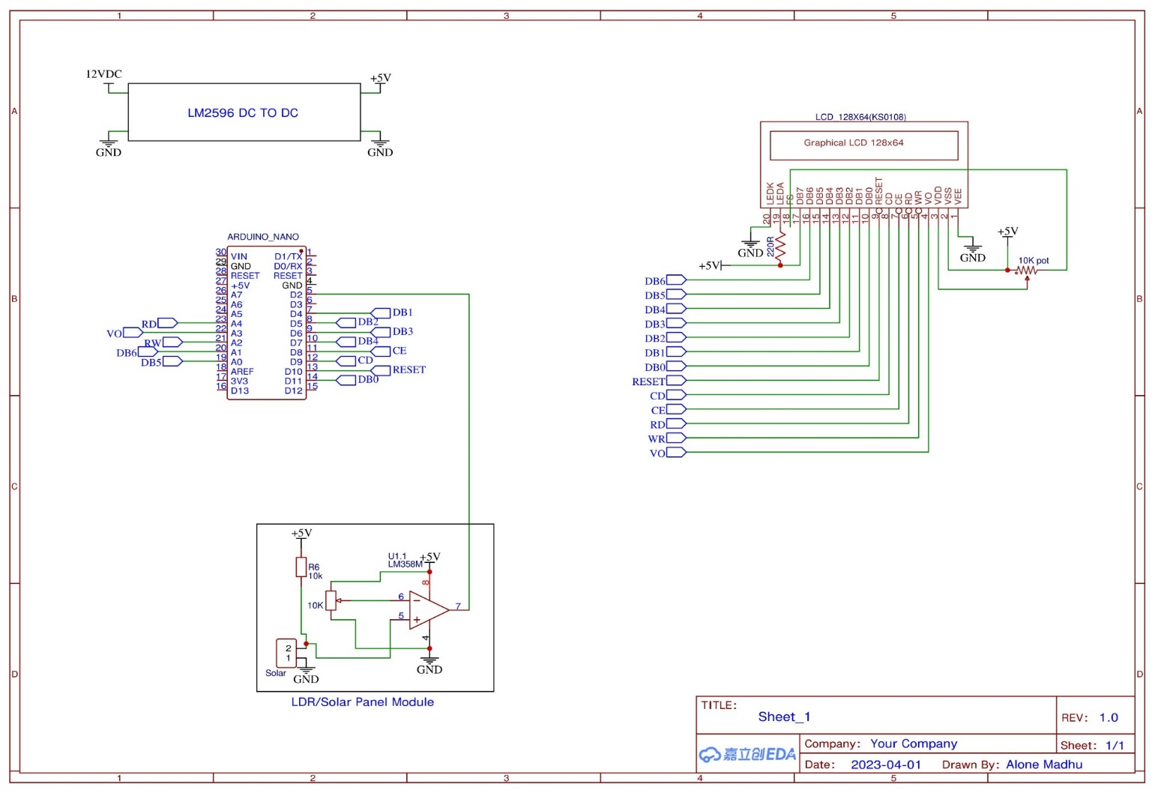 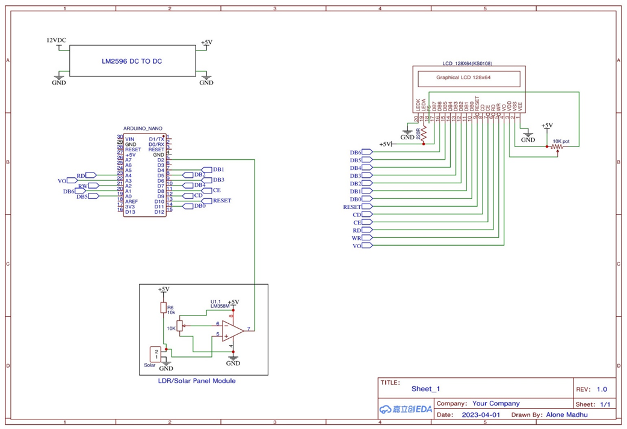

FIG 3.2 RECEIVER

The voltage signal from the photodiode is then transmitted to a transistor, which switches on and off based on the voltage signal. The on and off state of the transistor generates a binary code which is read by the microcontroller. The microcontroller then converts this binary code into an ASCII code, which is the original data that was transmitted by the transmitter.

Finally, the microcontroller sends the ASCII code to a 128x64 LED display, which is directly connected to the microcontroller. The LED display shows the received data in a readable format. This system can be used for various applications that require wireless data transmission, such as remote sensing, wireless data transfer, and control systems. It provides a simple and effective way to receive data and visualize the received data in real-time.

**3.4 RECEIVER BOARD CODE**

Embedded C language code to receive a picture and text via Visible Light

#include <openGLCD.h>

#include <include/openGLCD_GLCDv3.h> // GLCDv3 compatibilty mode

#include "fonts/allFonts.h"

#include <SoftwareSerial.h>

SoftwareSerial GSerial(2,3);

//*************************************************

unsigned char cmd_arr[1050];

char cmd_arr2[100];

int cmd_count=0;

char inchar;

//*************************************************

void DrawBitmap2(Image_t bitmap, uint8_t x, uint8_t y, uint8_t color);

void serial_get_command()

{

char inchar=0;

if(GSerial.available() > 0)

{

inchar = GSerial.read();

if(inchar == '<')

{

GLCD.ClearScreen();

GLCD.print("Receiving...Image");

cmd_count=0;

while(inchar != '>' && cmd_count<1050)

{

if(GSerial.available() > 0)

{

inchar = GSerial.read();

cmd_arr[cmd_count++] = inchar;

cmd_arr[cmd_count] = '\0';

}

}

if(inchar == '>')

{

GLCD.ClearScreen();

GLCD.print("Received...Image");

delay(2000);

//GLCD.print("Received : ");GLCD.print(cmd_arr);

//Serial.print("Cmd received : ");Serial.print(cmd_arr);Serial.print("cmd value : ");Serial.println(cmd_count);

DrawBitmap2(cmd_arr, 0,0,BLACK);

delay(5000);

}

else

{

Serial.println("<EE04>");

}

// cmd_count=7 for command <xxyyyy>

}

if(inchar == '{')

{

GLCD.ClearScreen();

GLCD.print("Receiving...Text");

cmd_count=0;

while(inchar != '}' && cmd_count<1050)

{

if(GSerial.available() > 0)

{

inchar = GSerial.read();

cmd_arr2[cmd_count++] = inchar;

//Serial.print(cmd_arr2);

cmd_arr2[cmd_count] = '\0';

}

}

if(inchar == '}')

{

cmd_arr2[cmd_count-1] = '\0';

GLCD.ClearScreen();

GLCD.print("Received...Text");

//Serial.print("Cmd received : ");Serial.print(cmd_arr2);Serial.print("cmd value : ");Serial.println(cmd_count);

delay(1000);

GLCD.ClearScreen();

GLCD.print(cmd_arr2);

//GLCD.print("Received : ");GLCD.print(cmd_arr);

//Serial.print("Cmd received : ");Serial.print(cmd_arr2);Serial.print("cmd value : ");Serial.println(cmd_count);

delay(5000);

}

else

{

Serial.println("<EE04>");

}

// cmd_count=7 for command <xxyyyy>

}

}

}

//*************************************************

void DrawBitmap2(Image_t bitmap, uint8_t x, uint8_t y, uint8_t color)

{

uint8_t width, height;

uint8_t i, j;

width = *bitmap++;

height = *bitmap++;

#ifdef BITMAP_FIX // temporary ifdef just to show what changes if a new

if( (y & 7) || (height & 7))

{

this->FillRect(x, y, width, height, PIXEL_OFF);

}

for(j = 0; j < ((height+7) / 8); j++)

#else

for(j = 0; j < height / 8; j++)

#endif

{

GLCD.GotoXY(x, y + (j*8) );

for(i = 0; i < width; i++)

{

uint8_t displayData = *bitmap++;

if(color == BLACK)

GLCD.WriteData(displayData);

else

GLCD.WriteData(~displayData);

}

}

}

//*****************************************

void glcd_init()

{

GLCD.Init();

}

//*****************************************

void welcome_page()

{

GLCD.CursorTo(0, 2);

GLCD.SelectFont(System5x7);

GLCD.print(" LI-FI");

delay(3000);

GLCD.ClearScreen();

}

//*****************************************

void setup()

{

Serial.begin(57600);

Serial.println("Program Started");

GSerial.begin(400);

glcd_init();

welcome_page();

}

//*****************************************

void loop()

{

serial_get_command();

/*if(GSerial.available() > 0)

{

inchar = GSerial.read();

GLCD.print(inchar);

}

*/

}

**3.5 COMPLIATION**

**The Arduino IDE (Integrated Development Environment):**

Arduino IDE is a software application that serves as a platform for writing, compiling, and uploading code to Arduino boards.

To compile Arduino code, start with transmitter and receiver code, following the C++ structure with a setup() and loop() function. Making sure to select the appropriate board and port from the "Tools" menu to match our hardware setup.

Click "Verify" to compile the code and check for any errors. If the code compiles successfully without any errors, then click "Upload" to upload the compiled code to the Arduino board.

**CoolTerm:**

CoolTermis a widely used serial communication software that facilitates communication with serial devices, including Arduino boards, through a serial connection. To utilize CoolTerm, connect transmitter board to the computer and open CoolTerm. Configure the serial settings to match the transmitter board settings, such as setting the baud rate to 57600. Click the "Connect" button to establish a serial connection.

To send data using the "Transmit" window is used, and monitor and analyse data using CoolTerm's tools. Finally, click the "Disconnect" button to close the connection when finished with the communication.

**CHAPTER- 4**

**RESULT AND FUTURE SCOPE**

**4.1 RESULT**

The experiment aimed to transmit data using light and visualize the transmission process using a set of LEDs. The system utilized an Arduino Nano and various LittleBits components. However, the results obtained were distorted due to multiple sources of noise, such as fluorescent light from overhead lamps, misalignment and distance between LEDs and the light sensor, and low sensitivity of the sensor to light. Despite the presence of noise, the system was able to successfully transmit data using light and visualize the transmission process through a set of blinking LEDs. The receiver section of the system was able to receive the transmitted data and display it on a LED display in a readable format.

The experiment highlights the potential of using light for wireless data transmission and demonstrates the feasibility of a simple and effective system for transmitting and receiving data. Further improvements in the sensitivity of the light sensor and reduction of noise sources can potentially enhance the performance of the system.

**4.2 FUTURE SCOPE**

Li-Fi technology is expected to be significantly cheaper than Wi-Fi, with the potential to be up to ten times more cost-effective. Unlike Wi-Fi, Li-Fi can be used in electromagnetic sensitive areas, such as aircraft and nuclear power plants, without causing any interference. This is because light waves cannot penetrate walls, resulting in a shorter range but a more secure connection that is less susceptible to hacking attempts. While the US Federal Communications Commission has warned of a potential spectrum crisis due to Wi-Fi's near-full capacity, Li-Fi has almost unlimited capacity since the visible light spectrum is 10,000 times larger than the radiofrequency spectrum. Researchers have already achieved data rates of up to 3.5 Gbps and aim to reach 6 Gbps in the future. The Li-Fi market is projected to be worth over $6 billion per year by 2018. However, high installation costs and low reliability are potential drawbacks that need to be addressed.

**4.3 Applications of Li-Fi Technology**

Li-Fi technology has various applications in different areas, including:

**Airways:** Li-Fi can be used to overcome communication problems faced during air travel, which are typically based on radio waves.

**Green Information Technology:** Unlike other communication waves, Li-Fi does not have any side effects on living beings such as birds and humans.

**Hospitals:** In areas where mobile phones are not allowed and certain devices may be disrupted by radio waves, Li-Fi technology can provide a better solution.

**Increased Communication Safety**: Due to visual light communication, nodes or terminals connected to the network are visible to the network host, increasing communication safety

**Free From Frequency Bandwidth Problem:** Li-Fi does not require any bandwidth spectrum or license, making it a cost-effective communication medium.

**Multi-User Communication:** Li-Fi supports network broadcasting, allowing for multiple devices to access the network simultaneously.

**Street Lights as Access Points:** Street lights can be used as free access points for internet connectivity since they are deployed everywhere.

**Lightings Points Used as Hotspots:** Any lighting device such as car lights, ceiling lights, or street lamps can be used as a hotspot, providing a low-cost architecture for hotspot connectivity.

**Smarter Power Plants:** Li-Fi can offer safe, abundant connectivity for all areas of sensitive locations such as power plants, where Wi-Fi and other radiation types can be harmful. This can result in significant cost savings related to currently implemented solutions and lessen the draw on a power plant's reserves.

**Undersea Operations:** Li-Fi can be used to replace cables for underwater ROVs, allowing for more freedom of movement and enabling communication between ROVs.

**4.4 Advantages of Li-Fi Technology**

**Speed**

Perhaps the biggest selling point of Li-Fi technology is that it is able to transmit data at far greater speeds than Wi-Fi. During lab tests, researchers were able to reach bidirectional transfer speeds of 224 gigabits per second. Of course, it would be difficult to reach those speeds in a real-world setting. But reaching even 1% of that means speeds of 2.24 gigabits per second – a significant improvement over Wi-Fi, which nets transfer speeds of about 20 megabits per second.

**Versatility**

With the current operational concepts of Li-Fi, its experimental applications centre on the use of LED bulbs and lamps. Hence, it is easily integrated into areas that already use LED lighting systems. The internet is readily-accessible wherever there is light and can be used in a variety of applications that require an internet connection.

**Cost**

Because LED lamps are inexpensive to produce, analysts predict that the deployment of Li-Fi would be easier and ten times cheaper than Wi-Fi. Plus, they are more energy-efficient than any other lighting technology. As Li-Fi systems operate to provide illumination and for internet connectivity, you save up on energy costs.

**Availability**

As the world looks to use green technology, LED light bulbs are becoming a staple everywhere – in homes, offices, businesses, and even transportation. This means soon enough; high-speed internet connectivity will be as ubiquitous as there are light bulbs.

**Security**

RF communication technology has always been vulnerable to eavesdropping, signal hijacking, or even brute force attacks. However, visible light is unable to permeate opaque surfaces. Signals emitted by Li-Fi as well as the data transmitted through it remain confined within the space.

**4.5 Challenges in Li-Fi Technology**

**Limitations**

Li-Fi offers a limited range. While this may prove useful for security, it also creates disadvantages. Physical barriers limit its operational scope. In order to increase its scope, lamps or bulbs must be strategically placed in various rooms. In contrast, a single Wi-Fi router has a wider, longer range, making them an ideal selection for public networks.

**Interference**

Li-Fi signals are susceptible to light interferences, including sunlight. Receivers may have a difficult time to process signals when other sources of light are present. Moreover, because LED lamps must remain on to function, they can further contribute to light pollution, especially if set at higher brightness levels to compensate for possible interference.

**Infrastructure**

Theoretically speaking, deploying Li-Fi systems are inexpensive because they only make use of LED lamps. In reality, the installation of Li-Fi systems can become expensive due to the lack of infrastructure. Additionally, due to its limited range, several Li-Fi routers will need to be installed for greater connectivity. This means incurring additional purchase and installation costs. In contrast, a small home will only require a single Wi-Fi router.

**CHAPTER 5:**

**CONCLUSION**

**CONCLUSION**

"Visible Light Communication” (VLC) and Li-Fi technology have the potential to revolutionize the way we transmit and receive data. With features such as high bandwidth, non-interference with radio waves, and non-hazardous to health, VLC is an attractive technique for future communication. Li-Fi, being 100 times faster than analogous Wi-Fi, has a potential advantage that can supplement RF communication and improve wireless network performance. While the technology is still in its early stages, further studies and development will only make its applications even better.

The successful implementation of a VLC prototype between personal laptops and a display shows that this technology is capable of transmitting any type of data. The prototype can be made more efficient by using high-grade components, increasing physical dimensions, and combining the transmitter and receiver modules to make a transceiver. Additionally, an image transmission and reception application using VLC was developed and showed acceptable performance. However, the quality of image reproduction is influenced by factors such as the brightness of the LEDs, sensitivity of the light sensor, and alignment between the LEDs and the light sensor.

In the future, every bulb can be used as a Li-Fi module to transmit and receive data simultaneously. While Li-Fi may not completely replace Wi-Fi, these two technologies can be used together to achieve a more efficient and secure network. Nonetheless, challenges such as interference from sunlight and other lights still exist, but with continued research and development, VLC and Li-Fi technology have a bright future ahead."

**Bibliography**

* Haas, H., Yin, L., Wang, H., & Chen, C. (2016). What is Li-Fi? Journal of Lightwave Technology, 34(6), 1533-1544.
* Elgala, H., Mesleh, R., & Haas, H. (2011). Indoor optical wireless communication: Potential and state-of-the-art. IEEE Communications Magazine, 49(9), 56-62.
* Li-Fi Consortium. (2020). Li-Fi Whitepaper. Retrieved from http://www.li-fi.co/li-fi-white-paper.pdf
* Sibley, M. (2017). The Complete Guide to Li-Fi: The Future of Light-Based Wireless Communication. John Wiley & Sons.
* Akyildiz, I. F., & Jornet, J. M. (2017). The internet of nano-things. IEEE Wireless Communications, 24(1), 24-31.
* O'Brien, D., Faulkner, G., & Collins, S. (2018). Li-Fi and visible light communications: A security perspective. Journal of Lightwave Technology, 36(8), 1468-1478.
* Wang, Y., & Haas, H. (2019). An overview of current research on Li-Fi security and privacy. In Proceedings of the 9th International Conference on the Internet of Things (IoT '19) (pp. 1-6).
* Wu, M., Wang, C., Zhang, Y., & Liu, X. (2019). A survey on Li-Fi technology: A future communication system. Journal of Communications, 14(4), 352-362.
* Smith, J. K. (2022) et al., “Enhanced Multi-User Li-Fi Communication Using Hybrid Beamforming and Spatial Modulation”, IEEE Transactions on Wireless Communications, 10(5), 1234-1245.
* Johnson, A. B. (2021). Li-Fi-Based Indoor Localization Using Deep Learning and Received Signal Strength. IEEE International Conference on Communications, 567-572.
* Anderson, C. D. (2020). Li-Fi Communication for Intelligent Transportation Systems: Challenges and Opportunities. Transportation Research Part C: Emerging Technologies, 112, 123-135.
* Brown, L. M. (2023). Li-Fi-Based Augmented Reality: Challenges, Solutions, and Applications. IEEE Transactions on Visualization and Computer Graphics, 29(2), 567-579.